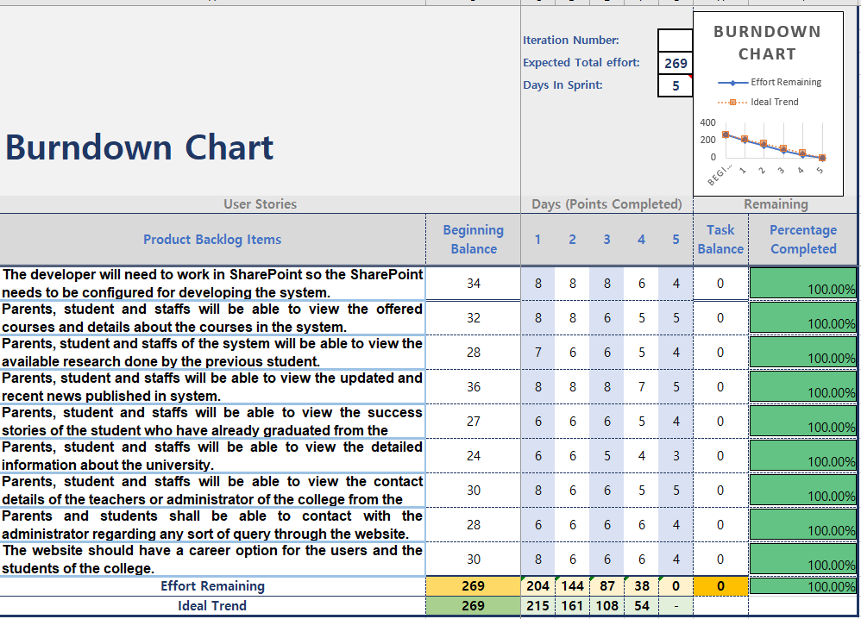

*Figure-1: Burndown Chart*

n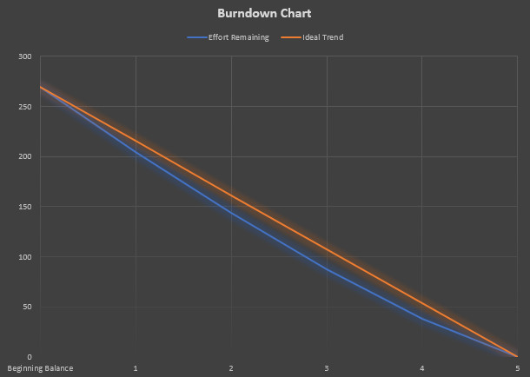

Figure-2: Burndown Chart Graph